Answer 1
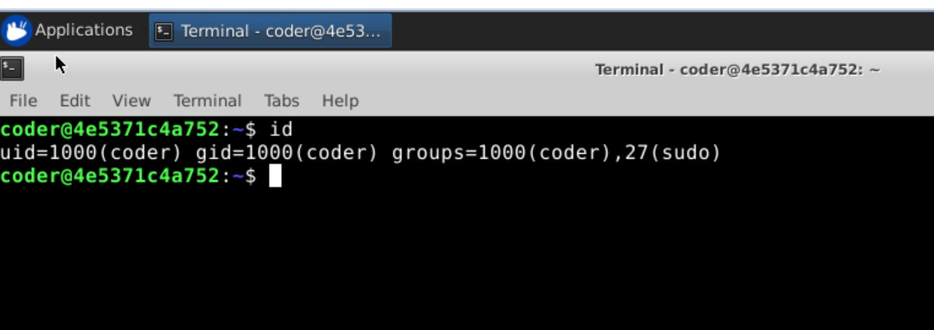
Explanation: Using id command we get currently logged-in username and all groups your user account belongs to. Desired output is shown above.

